Annex: Neighbourhoods and Localism
The Opportunity
Our communities and civil society are a source of great strength in our region, supporting the health, well-being, and life chances of our residents. But despite the best efforts of all involved, the two-tier system of local government is not enabling strong and empowered communities. Many residents believe that their areas have got worse. Fifteen years ago, 85% of residents said they were satisfied with their area compared to just 70% in 2025; and only 21% of residents feel able to influence decisions affecting their local area. The Essex Community Needs Index also highlights that some neighbourhoods have high levels of need and weak levels of resilience (as shown in the map below). This evidence collectively reinforces the argument that change is needed.
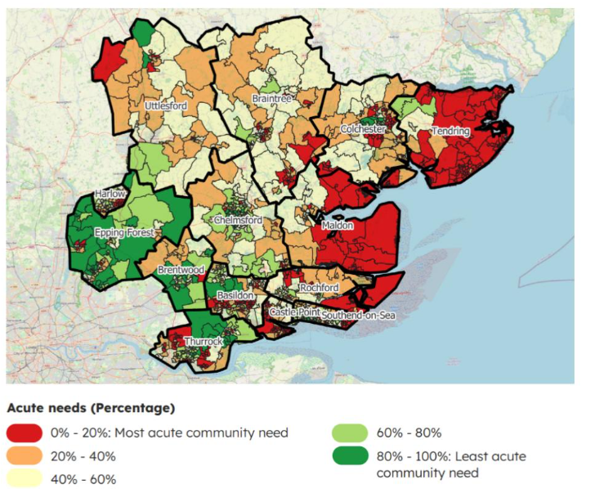
The opportunity is to bring service delivery and decision making closer to residents and through this to turn around the decline we have seen in some neighbourhoods. There are major reform programmes across public services in train to support that approach and now is the opportunity to capture the benefits of closer and more integrated working. The NHS 10 Year Plan will shift care much more towards prevention, anchored in communities. The policing focus on neighbourhoods reinforces this attention to relatively small natural geographies. The independent Essex Caring Communities Commission set out a bold vision for putting empowered communities at the centre of preventative practice and care. LGR offers an opportunity to reshape local government so that it becomes more responsive to local communities and so it can work more effectively with the NHS and Police as they also move to more local models of provision – based on geographies where it is sensible and possible to join-up services.
The Benefits of our Three Unitary Model
All new councils – whether they have 350,000, 500,000 or 700,000 people – will be larger than the communities or neighbourhoods they serve. What will make them local is not their overall footprint, but how they deliver services; their capacity to devolve power to communities; the support to local members to represent and advocate for their residents and places; the commitment to localism in their culture and ways of working; and their headroom to invest in communities and in the voluntary sector.
Our three unitary proposal achieves all these things and is therefore the most local proposal for Greater Essex. We are, for example, committed to ensuring that the voluntary and community sectors are at the heart of service delivery and community voice; that localism is embedded in new unitary councils’ culture and working practices; that new Neighbourhood Delivery Committees are set up to enable local voice in decision making; that a new Neighbourhood Delivery Fund is created with an initial £30m endowment; and that accountability is clearer and streamlined with fewer unitary councillors than current county/district councillors, enjoying enhanced support.
We fully support and are following the five design principles that were set out in the Joint Statement from the Essex Community Foundation and Local Infrastructure Organisations, which informed our proposal for LGR.
Our proposal is based on the existing district boundaries and we are not proposing any changes to those boundaries as part of our submission. However, we would wish for the Boundary Commission to undertake an urgent and early review of our arrangements with a particular focus on the Wickford area of the South Unitary. In particular, we would like the Boundary Commission to consider the district wards of Castledon and Crouch, Wickford Park and Wickford North. These wards are currently within the Borough of Basildon and therefore in the proposed South Essex authority, but we would like the Commission to consider moving them into the proposed Mid Essex authority for the reasons set out in our proposal.
Devolving decisions to neighbourhood level
Localism is embedded through Neighbourhood Delivery Committees (NDCs). These will have a substantive set of powers in a number of areas:
- Community assets: NDCs will give communities a real say over how local community assets are managed, such as community centres, local parks, sports grounds, play areas etc.
- Local services: NDCs will give communities a real say over how local community services are delivered, for example minor highways functions, fly-tipping, leisure, community safety.
- Influence: NDCs will enable communities to have input to more strategic service or policy decisions that are not devolved down, but where local voices still need to be listened to.
- Local projects: NDCs will allocate funding for local projects that reflect community priorities. There will be an initial £30m endowment to support the operation of the NDCs.
- Scrutiny: NDCs will act as scrutiny bodies, playing a role akin to local place-focused scrutiny committees and holding portfolio holders and partners accountable for local service delivery.
NDCs will be led by local elected councillors and will include partners such as NHS, police, housing providers, parish councils, businesses, and the voluntary sector. Public participation will be actively encouraged. This approach responds to residents’ desire for decisions taken close to where they live and builds on Essex’s strong record of community-led initiatives.
Strengthening the role of elected members
The proposed 3UA model introduces a streamlined councillor structure, reducing the total number of councillors in Greater Essex from 700 to 284. Each division will be represented by three councillors—except for one division in Southend-on-Sea, which will have two—resulting in an average of 4,839 electors per councillor, which is in line with national guidelines.
To maintain strong local representation, the model includes a commitment to enhanced support for councillors. This includes ongoing training and development to strengthen decision-making; investment in digital tools to improve engagement and accessibility; and improved access to local service data to inform community priorities. Councillors will lead NDCs, ensuring strong local representation and accountability. This approach will strengthen the visibility, responsiveness and accountability of local politicians who can effectively represent their communities both online and in person.
Community Investment
Communities need a voice but they also need targeted investment. The three unitary model creates more financial savings than other models – with net financial benefits estimated at £86m after five years. This will enable money saved from LGR to be re-invested into public services and into communities, with NDCs being supported by an initial endowment of £30m to support neighbourhood-level initiatives. Resources will also be channelled into community infrastructure, such as community hubs, and into more local delivery models for public services.
Parish and Town councils
Under LGR, parish and town councils will remain key components of local democracy. Our proposal actively champions and supports parish and town councils, and we envisage them being full participants in the new NDCs. In this way the work of the new councils at a local level will be much more joined up with parish and town councils, to the benefit of residents, than it is now.
VCS
The VCS is a key partner in the achievement of good outcomes in places – both at a strategic and at a hyper-local level. Their role will be enhanced through our proposal for LGR, by ensuring not only that the VCS is properly linked to new models of neighbourhood working, but also that the new unitaries support an effective and financially sustainable sector for the long-term.
Our model provides the strongest possible basis for supporting and working with the voluntary and community sector going forward, providing financial stability to fund collaborative working arrangements; reducing partnership overheads and the costs for small organisations of working with multiple agencies; committing to neighbourhood level working to allow local VCS organisations to flourish; and engaging with the VCS as a key partner throughout this transition.
Concerns with the other Greater Essex LGR proposals
The five unitary model in particular maintains that because its councils are smaller, they are therefore “more local”. This is not the case. A council of 500,000 is not meaningfully more local than one of 650,000. As outlined above, the key determinant of how local a council is, is how the new councils choose to deliver services and construct their operating models.
Our localism concerns around the five unitary proposal in particular are two-fold. Firstly, the prevailing assumption that Councils of 300,000+ are local suggests a less serious commitment to devolving power further down to neighbourhoods. The five unitary proposal does include Neighbourhood Area Committees, because this was a requirement from government, what is much less clear is whether NACs in the five unitary model will have anything like the role and powers that they will in our three unitary model, or whether their NACs will quickly whither away, as they have in some other councils.
Second, the more unitary councils that are created, the more they will cost. A system of five unitary councils will actually cost more to service than the current system of government in Essex. After five years, five unitaries has a net cost of £114m (compared to a net saving of £86m under our model).
Councils in financial difficulty and faced with rising statutory demand in social care will simply not be able to increase or even maintain investment in communities and the voluntary sector – they will have to reduce service-focused spend to balance the books. This will impact on the VCS, on civil society and on the wellbeing of communities themselves.
The four unitary proposals do not raise the same stark concerns as the five unitary model, but they will result in fewer savings and less financially sustainable councils than under the three unitary model.
Conclusion
Greater Essex is a diverse area and our diverse communities are a tremendous asset. LGR needs to work in partnership with changes to the NHS and Policing to bring service delivery and decision making closer to communities. The key to this is not to focus primarily on the size of the footprint of the new councils, but rather to look beneath this into how they will operate in practice – whether they will have the capacity to devolve powers to communities, and whether they will have the financial resources to invest in communities and in local partners and the VCS.
Our three unitary proposal will be the most local proposal for Greater Essex because it will create Neighbourhood Delivery Committees based on real places, with real powers, and supported with real money - a £30m endowment. It will strengthen the role of and support to elected Members; it will strengthen collaboration with local partners, including the VCS and parish and town councils; and it will create the financial headroom to increase investment in our communities in a way that no other proposal can do.

