|  |  |
| --- | --- |
| **Report title:** Enabling Citizen Led Communities | |
| **Report to:** Essex Health and Wellbeing Board | |
| **Report author:** Kirsty O’Callaghan | |
| **Date:** 17/09/2020 | Discussion |
| **Enquiries to** Dr Mike Gogarty, Director of Public Health, Kirsty O’Callaghan, Head of Strengthening Communities: kirsty. o’callaghan@essex.gov.uk | |

1. **Purpose of Report**

We have a vision to develop Sustainable Communities with people in Essex. Our vision is “to transition the council from service-led to a citizen-led approach to improve Health and Wellbeing, with sustainable shared approaches led by communities themselves.”

This paper is for information and consideration, it seeks to set out a 2 - Year approach to truly bring the vision above to life focusing on the enablers below:

* Digital First Communities of Place, Purpose and Identity
* Re-imagining Volunteering
* Transforming Local Infrastructure
* EALC Parish Activation Programme

1. **Recommendations**

To discuss and support the next phase of planning and delivery of the recommended next Steps for Reimagining Volunteering, Parish Activation and Transforming Local Infrastructure Programme in Section 5.

1. **Summary of issue**

**Why We Build Community?**

Community means belonging to a place, a purpose or an identity. When we talk about building community we are talking about the construction of environments, both physical and digital, in which a sense of mutual belonging is felt. As a council we believe that our role is that of facilitator to build and grow pathways to community driven solutions for citizens so that they can address self-identified societal issues in alignment with our key challenges as a local authority. We believe in honest, open communication which allows for constructive challenge and accountability across all sectors. Developing community requires bravery, it requires a willingness to adapt and change at pace in order to meet the needs of the citizens and the local authority. It is not always easy, but it is always, when done right, impactful.

**How We Build Community?**

In 2014 ECC published the Who Will Care report which contained 5 high-impact solutions. These high-impact solutions were designed to produce successful outcomes for:

* more effective and earlier identification of your needs including support for you to self-identify;
* seamless care and support for all Essex people;
* giving back to you the ownership of your health and care and reducing all our dependence on the State;
* value for your money.

We aligned the 5 high-impact solutions with our community objectives to make them the guiding principles of developing community driven resources in the following way:

1. Forge a new understanding between the public sector and the people of Essex.
2. Identify and address societal need in collaboration with citizens
3. Mobilise community resources through citizen led initiatives.
4. Use data and technology to the advantage of the people of Essex in a digital first approach.
5. Ensure clear leadership, vision and accountability from citizens and the local authority.

**Community Development Cycle**

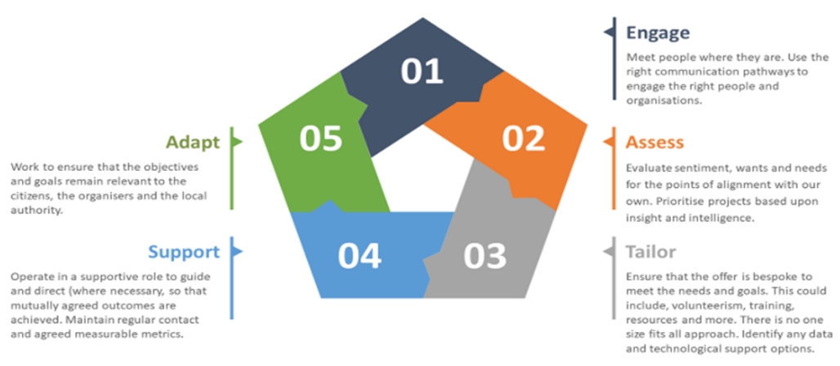

**Fig 1: Community Development Cycle**

**Covid-19 as a Catalyst**

Covid-19 presented our teams and partners with significant challenges and opportunities. Whilst the pandemic has been terrible for many across Essex, it has also presented us with a situation where we had to be less risk averse, be brave not perfect, in order to mobilise both Community Hubs and the Essex Wellbeing Service. The Community Action Pyramid on page 3 shows the different cohorts of providers and actors within the Community Sector in Essex.

**The Community Action Pyramid**

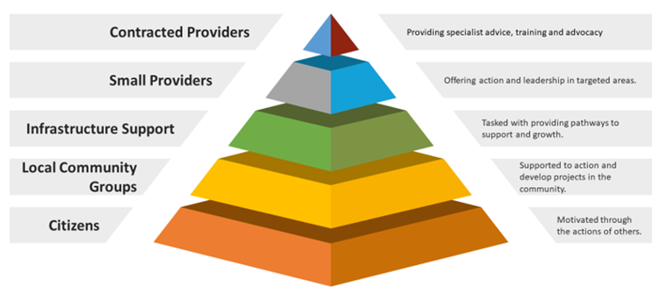

**Fig 2: The Community Action Pyramid**

We have previously focussed on the top two tiers of the pyramid where we can exert more direct control contractually. However, Covid-19 has shown the potential for us to develop a new model of civic infrastructure that seeks to curate and galvanise citizen led services and initiatives at scale. In order to do this, we will need to focus on three things:

* Expansion of the Community Campaign model to meet people where they are to create a sense of belonging across communities of place, purpose and identity
* Investment and transformation in local infrastructure organisations including CVS partners, Parish Councils and the Rural Community Council of Essex
* A re-imagining of our Volunteer Ecosystem

**Learning from the Coronavirus Crisis**

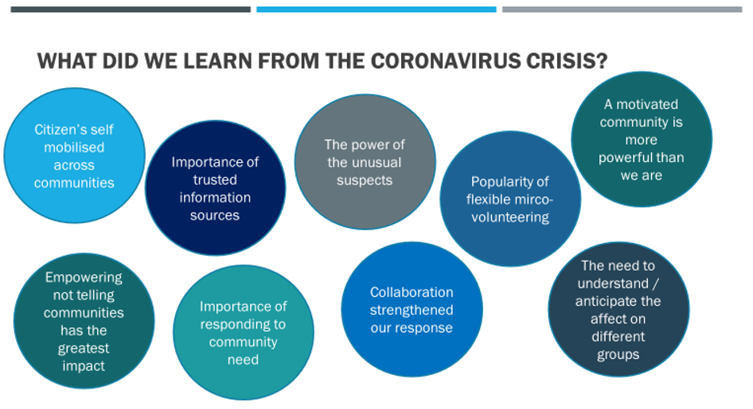

**Fig 3: Learning from COVID Communities**

**Why build Citizen led initiatives:**

Many of our key societal issues require a response that can reach people at scale.

**Historic Commissioned Services**

* Struggle to engage at the scale needed to achieve a population impact, for example:
* 1 in 7 people in Essex – nearly 100,000 residents identify as lonely
* In 2018/2019 our Live Well Link Well service saw 10,000 people representing 10% of the need in our communities. The following year 2019/20 with the introduction of the Community Campaign Model, United in Kind saw figures rise to 33,000 people

**Communities**

* Communities themselves often have a greater understanding of their needs and how to help each other than local services.
* Community led interventions help people connect, creating an enhanced sense of belonging
* Increase resilience for residents in Essex
* Improve wellbeing and mortality rates

The Sustainable and Healthy Communities plan intends to **move the council from a referral driven model to a self-start, self-organised, self-joined service.**

**The Potential of a Citizen led Service**

**A Citizen-Led Service can be achieved by**

* providing an infrastructure and culture of accessible volunteerism that supports “grassroots development”
* up-skilling our communities to support themselves and one another
* overlaying programmes in areas designed to tackle issues such as domestic violence, learning disabilities and mental health
* encouraging and supporting citizen-led action to address local needs
* providing a platform for peer-led interventions that target community need alongside organisational challenges e.g. green lifestyles, family support, weight management etc

**The Approach**

* create a ‘digital-first’ offer for Essex using existing social media platforms e.g. Facebook and Twitter
* investigate the potential of artificial intelligence as it matures
* we will target specialised programmes in the localities and specific communities with highest needs to improve wellbeing, aspiration and achievement.

1. **Transformation Enablers for Citizen Led Communities**

**4.1 Community Campaign Model**

The Community Campaign Model can be implemented for communities of interest, place or purpose. It is a new approach to civic infrastructure which seeks to align the wants and needs of the community with the objectives of the public sector. It creates a social movement around societal issues which engage and mobilise citizens to provide solutions for themselves with the support of local authorities. The most recent example of this is with the Essex Wellbeing Service, where an army of **over 7,000 volunteers** were mobilised in under a month to support the citizens of Essex during the Coronavirus crisis. To date EWS volunteers have completed **over 12,000 tasks** in under four months with **most tasks being picked up in under one minute.**

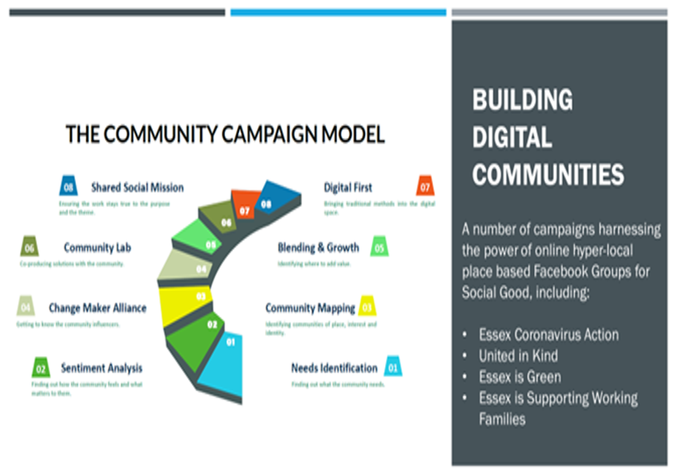

**Fig 4: Community Campaign Model**

**The Model in Action**

One of the strengths of the Community Campaign model has been the ability to collaborate directly with citizens and get out of our own way. It enables us to reach people where they are. Facebook Groups have allowed Essex County Council to re-frame the relationship with people in Essex, to listen, engage and create a shared sense of belonging with citizens.

We don’t need to create platforms that cost vast amounts of money – to then not ever have the budget to drive people there to engage with them, we have a free resource that can be used for Social Good. Although very cost effective as a model, we recognise that digital is not the only answer, Yet, it is a key enabler to connecting with people and pulling them into a space where we all align behind similar societal issues. We will continue to utilise and scale this model to encourage citizen led initiatives around shared social missions of purpose.

**Digital Community Campaigns**

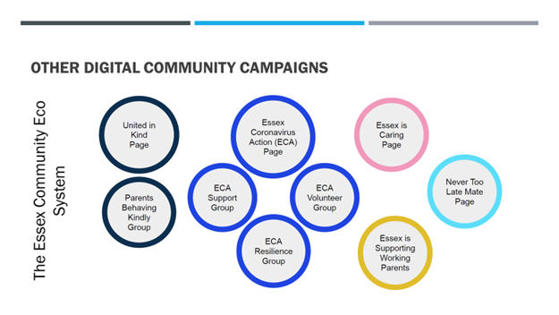

**Fig 5: Essex Community Campaign Ecosystem**

**Essex Coronavirus Action**

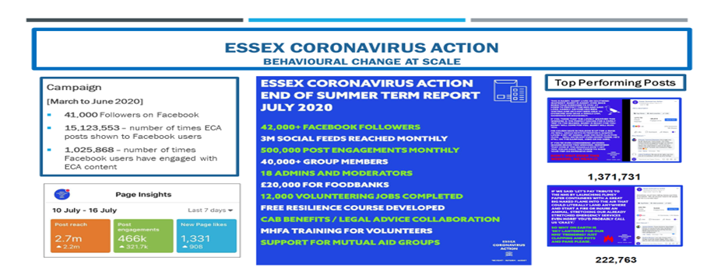

**Fig 6: Essex Coronavirus Action Campaign Highlights**

**4:2 Re-imagining Volunteering: Citizen Led Volunteering**

The Coronavirus outbreak afforded us a unique opportunity to mobilise our citizens as a volunteer force with a common goal. Our efforts across the system were so successful that we were able to recruit far more volunteers than were needed. Our challenge has been, and continues to be, maintaining the engagement of these volunteers while matching their willingness to help to available need in a structured way. As we move past the initial crisis phase of Coronavirus it should be our mission in Essex to build upon the citizen led efforts generated to date and move forward with a new model for volunteerism in Essex.

The benefits of volunteers within the system are well documented, however, we also need to ensure that a new volunteering model for Essex demonstrates clear benefits for volunteers as well. A volunteering model that offers opportunities to learn new skills, to make new connections and helps to address inequalities. Where there are clear multichannel pathways into volunteering and a system in which volunteers feel supported and valued.

This mission should not just be for ECC and how we support citizens in services such as Adult Social Care, Children and Families and Public Health through individual micro-volunteering, but truly seek to develop a citizen-led approach that also supports mutual aid groups and broader community volunteering. It is about creating the right conditions to maximise the opportunity to mobilise citizens, underpinned by a formal offer, incorporating micro-volunteering alongside more traditional types of volunteering aligned around communities of place, purpose and interest. Understanding where statutory intervention adds value and offering support, as required, to galvanise “neighbourliness” in a safe way for both volunteers and the community.

We are proposing that we initially form an internal **Discovery Taskforce** to begin to reimagine the future of volunteering in Essex. The Discovery Taskforce will seek to collaborate with others in the system to address the following areas both cross-departmentally and cross-agency:

* develop a specific understanding of what different parts of the organisation and broader system want from volunteering and what their involvement currently looks like. What are the successes and where are the challenges?
* develop an understanding of the motivations for volunteering and how to help support people to remain engaged with volunteering
* understand the projected need for volunteering now and in the future.
* establish what volunteer brokerage looks like now and what it should be in the future.
* address the differing needs between impact volunteering and micro-volunteering with use cases for each
* reimagine a simplified, tech driven, user focused volunteering infrastructure which engages the community and inspires creation of new volunteers. To include the roll out of Tribe. Tribe is an intelligent app which was developed to address the issue of care dark spots in the UK. In a nutshell, it is Uber for the care and volunteering sectors. Community driven, it places the power in the hands of residents to ask for the help that they need and be matched with people to provide that help. Through industry-leading Artificial Technology, Tribe has inbuilt capabilities to learn and respond to resident and community needs giving deep insight into where help is most needed. All of this is supported by a full suite of analytics which allows organisations and commissioners to undertake predictive needs analysis in real-time.
* Provide a simplified, on-demand training solution and transparent volunteer management structure.

**The Challenges of Volunteering**

In our busy, fast paced world where people feel increasingly disconnected from their local communities, volunteering is integral to addressing both societal need but also to fostering a sense of belonging.

Engaging with our pool of EWS volunteers to establish why they hadn’t volunteered before EWS they cited reasons such as lack of time, not knowing how to help, and not wanting to be tied to a regular volunteering commitment. However, when surveyed, over 60% of EWS volunteers who had not volunteered before wanted to find a way to continue doing so even after the crisis had passed.

It is critical that we establish the needs of and challenges for each entity in order to craft the correct solutions for the future.

|  |  |
| --- | --- |
| **Volunteer Brokerage in Essex** |  |
| **Currently** | **In the Future** |
| ● Diverse, many organisations have a volunteering component.  ● Formal, uses a traditional model and has not moved into newer methods of volunteering (e.g. impact, supported, micro)  ● Time consuming, requires disproportionate input in relation to output  ● Niche, does not reach a multi-demographic audience | ● Agile, able to adapt quickly to changing needs and situations.  ● Flexible, to meet the needs of impact and micro-volunteering initiatives.  ● Digital First, taking advantage of new technologies to leverage the power of connecting people to opportunities.  ● Cohesive, maintaining an individual presence underneath a distinct and recognisable countywide brand. |

**Note:** this is not about ECC managing all volunteers or precluding local action/activity around volunteering, but using these underlying principles to develop a system wide approach

**Re-imagining Volunteer Structures in Essex**

Our engagement with EWS Volunteers has provided insight into what is important to them. Further exploration with VCSE partners to expand our understanding of the challenges of volunteering, to include insight into the volunteering profiles within their own volunteer pools, will help to develop a collaborative view of volunteering across Essex and help to re-imagine volunteering in Essex.

While structures and systems are already in place to facilitate volunteering in Essex, we are now faced with the huge challenge of channelling the energy of our new volunteer force alongside their desire for a more flexible, fluid volunteering system. Our engagement with EWS Volunteers has shown that micro-volunteering has been proven to be a key part of our Coronavirus response efforts and we are keen to grow that while still ensuring that existing models of volunteering continue to be relevant and valid. To do this we have developed the Community Action Pyramid in Fig 2.

We know that maintaining volunteer engagement levels is integral to the continued success of volunteer efforts in Essex. Through working with the Essex Wellbeing Service volunteers, we have been able to identify four key components which are essential to maintaining volunteer engagement. Fortunately, many of these elements are already in place we just need refinement and coordination in order to grow their impact for volunteers.

**The Elements of Successful Volunteering**

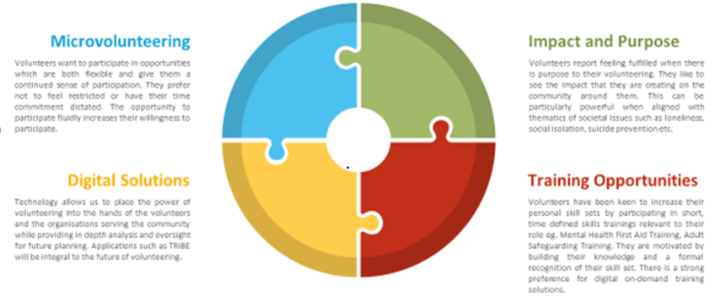

**Fig 7: The elements of successful volunteering**

**What’s next?**

In order to secure a solid foundation upon which to build the next iteration of volunteering in Essex it is essential that we work with existing structures while innovating to meet the needs of our new volunteer force**.** It is proposed that a new volunteer function is created which will provide a pivotal communication function between the volunteer force, existing infrastructures and ECC.

It is our intent that we will pull together a Task force of any interested partners, community groups and citizens to shape future volunteer provision across the county. Our intent is to be entirely inclusive and operate this work programme in the same way that led to the co-production of the Social Isolation Forum, all interested partners will be able to register their interest and participate in this work.

PROVIDE has been commissioned to lead the ongoing management of Essex Welfare Service volunteers. The scope of this work relates to the development of a robust coordination service for EWS, but seeks to support the wider volunteering offer, supporting partners and communities to develop a robust and coordinated volunteer offer. In doing so we will be able to continue to engage and mobilise a citizen driven volunteer force for the future. PROVIDE will also be responsible for the initial rollout of TRIBE.

|  |  |
| --- | --- |
| **Discovery Task Force** | **A communication strategy will be developed based on the information provided by the Taskforce.** |
| As a priority, the teams involved in the Discovery Taskforce with the assistance of PROVIDE will establish a smaller exploratory subgroup to define the current spectrum of volunteering opportunities currently available in Essex.   * This specific sub-group will be tasked with establishing and defining the volunteer pathway in the first iteration. * This research will begin immediately in order to provide a foundation for the subsequent work. * The results from this work will inform the next steps of the Discovery Taskforce. | It is proposed that:   * Communication is split into short, medium- and long-term goals with an appropriate strategy assigned to each. * Messaging will be aligned against the framework of each organisation. * Communication will be amplified through existing channels in order to feed an overall umbrella brand. |
| **Predictive Modelling** |  |
| Predictive modelling will seek to facilitate accurate measurement of:   * Future needs * Scope of roles * Time commitments * Skills and availability gaps |  |

**Raising Awareness of Volunteering**

It is important that any new iteration of volunteering in Essex is supported with a suitable campaign to raise awareness. This campaign should seek to sit alongside and amplify existing initiatives and organisations e.g. Volunteer Essex.

Following the already successful Community Campaign Model the campaign would seek to raise awareness of and engage residents in volunteering.

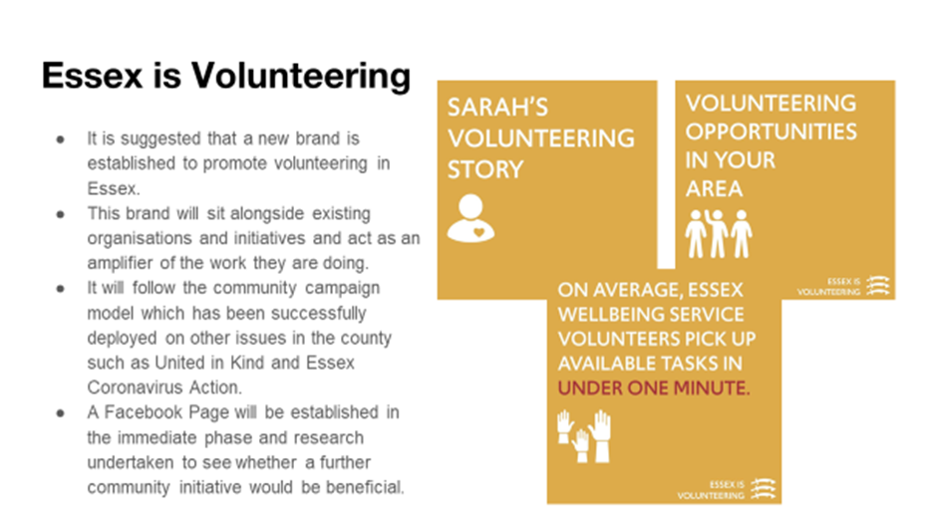

**Fig 8: Essex is Volunteering**

* 1. **Enabling Citizen Led Communities – Parish Activation Programme**

*Content Provided by the Essex Association of Local Councils [EALC]*

There are 275 Parish and Town Councils within Essex which covers approximately 53% of the county. Of all these Local Councils, few operate in the same way. Some are large and meet every week with a varying number of committees and some meet every two months and have 4 paid hours of officer time to do all their work. What they do all share is that the councillors are made up of volunteers from their communities.

Pre Covid19 all councils met in public and had always done so. The change to meeting in an online capacity has been seen as advantageous to some and a distinct barrier to others. However most have moved to an online capacity and this has given EALC an opportunity to reach them for training without the barrier of travel. To take advantage of this EALC has created short online forums and are working towards webinars too.

Online Health and Wellbeing Forums

These forums concentrate on the ‘added value’ aspect of creating a Health and Wellbeing Plan. We have created a template to give local councils something to work with and in it we provide links to other partners.

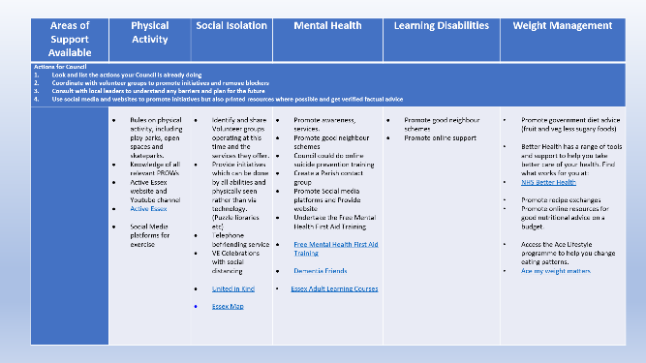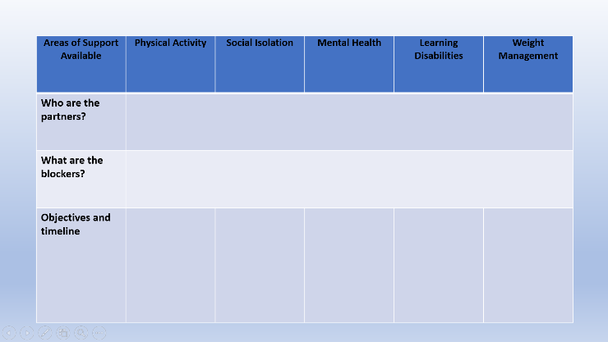

**Fig 9: Example Health and Wellbeing Plan**

Once the local councils have completed the plans, they are asked to publish them as a living document for their residents. They are asked to consider what they have in their parish and how they can either add to it or what they can do to make it more accessible. Where they can identify gaps in provision for particular elements of their society, they are then given information on partners they can work with to create initiatives. We have held 8 of these forums so far and have received 15 plans directly to EALC with others being published straight to the local council’s websites.

**Resource Packs**

To help give local councils an idea of some of the larger partners they can work with, we have created a Resource Pack, with information on what the partners do and who the councils can contact but also who the councils can direct residents towards. This 13-page document has allowed local councils to see how many partners there are and what they do. It is also giving them the information they need to support community groups and residents.

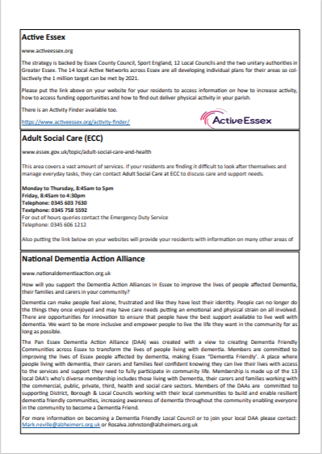

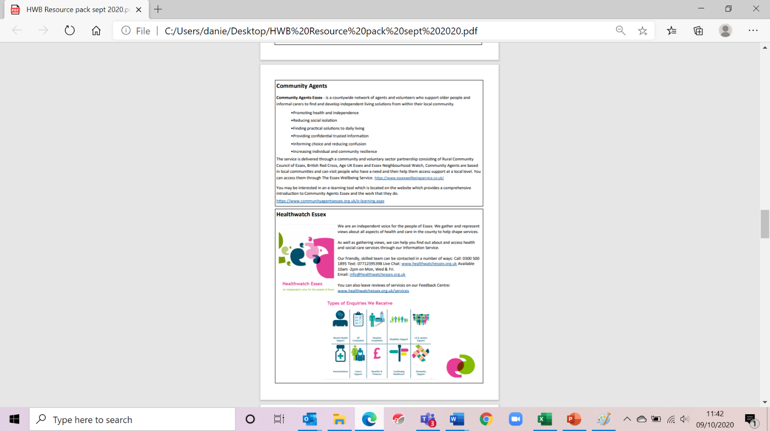

**Fig 10: Resource Pack**

**Online Training**

We have worked with partners to promote the Mental Health First Aid, J9 and Suicide Prevention training. It is important for councils to understand that through this training they will be able to adapt or create new initiatives with confidence to meet the needs of their residents. Over 60 local councils have undergone the mental health first aid training, and many are promoting it on their own website and social media pages. We have asked J9 to produce a short video for us to circulate to our members to explain the value of the training.

Conferences and Publications

To increase the publicity on Health and Wellbeing we have written two articles for magazines which are circulated directly to the local councils and have presented at the NALC conference.

Inspire the Younger Generation to Engage in the Voluntary Sector

To increase volunteering engagement from the youth sector we are encouraging all Local Councils to have representatives from their councils who meet regularly with the educational facilities within their parishes. This would include all schools and youth groups.

The aim is to facilitate a constructive dialogue with the younger residents to understand what they need, what they are worried about and how the Local Councils can meet those needs or petition other tiers of government to remove any blockages. It also creates a real understanding of the costs and value of being engaged in where they live. We are encouraging Local Councils to give ownership of projects to youth representatives as evidence shows that this removes the barrier of them feeling disenfranchised and promotes the fact that their opinions count. Where possible we are encouraging Local Councils to facilitate Youth Councils and at a minimum to have a youth representative attend their council meeting on regular occasions to give a report.

Future Collaboration between the Local Councils across Essex

We are moving forward with our programme to disseminate information to the Local Councils both on initiatives and working with our partners. We are also encouraging and supporting Local Councils to link together on initiatives, especially if they are smaller councils. For example, one Parish may want to provide lunch to the vulnerable and a nearby Parish Council with no premises may financially support transport for their members to go to the lunch.

Many Local Councils have benefitted from an increased prominence due to the Covid-19 pandemic. They have made or strengthened links with Community Hubs and Community Groups to make sure that accurate information is given out and that they are supported financially if necessary, we are giving them ways to grow this. At EALC we value the collaboration we know comes from our training programme and have created and maintained regular forums between Clerks and Chairman. This was very useful with the opening of halls and premises, as advice and sharing of information provided confidence to our members.

We are working very hard to capture that feeling of moving forward and looking constantly at the ‘bigger picture.’

|  |  |  |
| --- | --- | --- |
| **Events** | **Participants** | **When** |
| **Forums** | We are creating forums parishes to attend for:  Active Essex  CVS  Dementia Friendly Communities  HWB Forums | 2020 |
| **Webinars** | Contacting all our larger partners to get short videos on their services for our website | 2020/2021 |
| **Website** | Creating a Health and Wellbeing page and publishing information from partners and also good news stories. | 2020 |
| **Conference** | Holding a Health and Wellbeing Conference for Local Councils | 2020 |
| **Social media courses** | Running courses on **How to** create Facebook, Twitter, Instagram etc. account and how to manage them. | 2020/2021 |
| **Promotion of good news stories** | Working on a County Update promoting all those Local Councils who have created a Health and Wellbeing Plan and the good works which have come out of the plan and partnership working | 2020 |
| **Funding** | Promoting all funding streams available | continuous |
| **Social Media** | Making regular use of our social media streams to promote Health and Wellbeing issues. | continuous |

**4:4 Transforming Local Infrastructure**

An effective infrastructure offer, to support and grow the grassroots “citizen” and “local community group” activity that underpins the structure, is essential to the development of a “citizen-led approach”

Currently the infrastructure offer in Essex is through 12 CVS and 12 Volunteer Centre partners. As we move towards a “citizen-led” approach we need to look at how this current model needs to adapt to support this new “citizen-led” approach. A model that enables and ensures effective support, not just to those at the top of the pyramid but those supporting it.

**The Current Infrastructure Offer**

The ask of our CVS partners has been diverse. Outcomes focussed on Public Health priorities alongside upskilling and supporting communities to develop new activity to address a variety of societal challenges. The ask of our Volunteers Centres over the past year have sought to broaden the volunteering landscape with outcomes focussed on growing micro-volunteering, supported volunteering and embrace a digital first approach etc.

Our CVS and Volunteer Centre partners have worked incredibly hard in adapting to change over the last 3 years and supporting the Covid-19 response across Essex, this work has been truly exceptional.

**COVID Local Hub Response - overall CVS and Volunteer Centre Data**

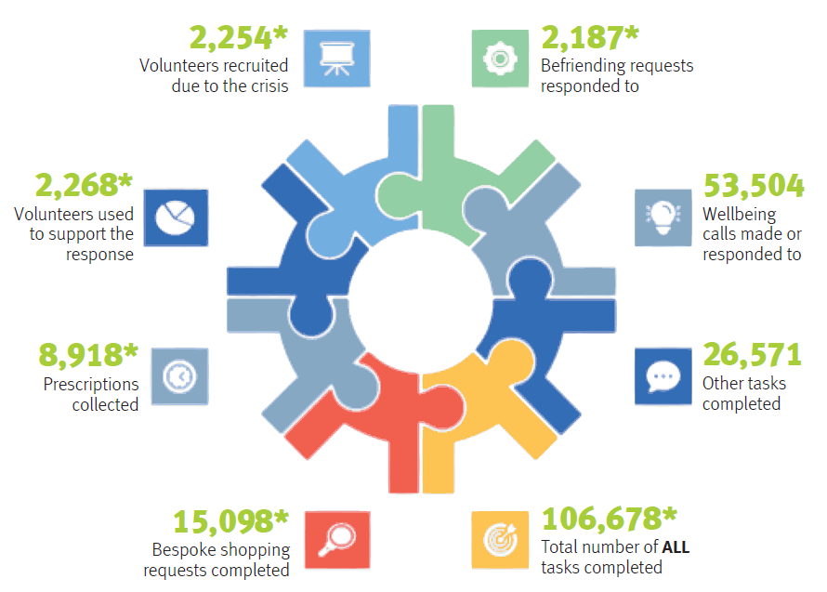

*Data from 10 CVS partners

**Fig 11: COVID Local Hub Response**

Within the current ask of our infrastructure offer there are outcomes that provide insight into the journey so far towards developing a “Citizen-Led” approach. These key outcomes demonstrate current performance and act as a baseline for discussions to develop a “Citizen Led” approach. In the Fig 12 we have highlighted the current performance submitted in 2020/2021 from our CVS and Volunteer Partners.

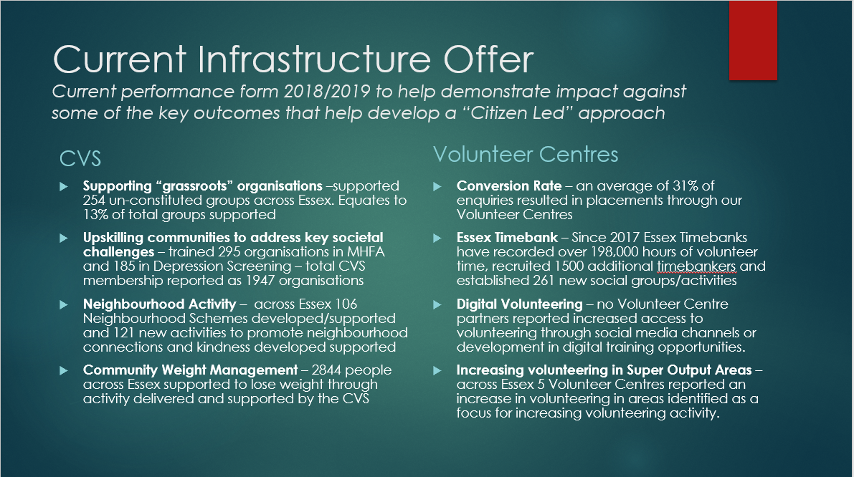

**Fig 12: Current Infrastructure Offer**

We now need to build on the learning and performance thus far to understand how the infrastructure needs to adapt to ensure that a future infrastructure offer can build on success to date and deliver at scale to support the conditions necessary to develop a “Citizen Led” approach.

The below bullets provide a road map and ethos to better support an accessible infrastructure model from 2022/23

* Support and creation of a discovery/co-production group with partners to understand what is required for local infrastructure in the future
* Profiling and modelling of an investment case to support local infrastructure moving forward beyond 2022/2023
* Delivery of a co-produced piece of discovery work, in collaboration with CVS partners and their networks, to ascertain the wants and needs of citizens and community groups to support citizen led activity to be delivered by the Essex Alliance
* Greater investment in training and talent management
* Ensuring a culture where infrastructure delivery is seen as neutral and not as market competitors by local groups, essential to creating truly citizen led communities
* Supporting better use of digital and accessibility for those who wish to support and empower their communities

1. **Next steps**

Recommended Next Steps for Reimagining Volunteering, Parish Activation and Transforming Local Infrastructure Programme:

|  |  |  |
| --- | --- | --- |
| **Short Term (Month 1)** | **Medium Term (Month 2-3)** | **Long Term (Month 4-24)** |
| * Engagement with and sharing of existing volunteer findings e.g. EWS and Hub Volunteers * Robust communication plan to engage and rally existing volunteers. * Showcase of potential volunteer opportunities and volunteer pathway. * Commissioning of Provide to supply volunteer management in relation to the Essex Wellbeing Service. * Co-production Group Established with Districts and Essex Association of CVS to shape future model * Ongoing delivery of Parish Activation Programme with Essex Association of Local Councils (EALC) | * Discovery Taskforce mobilised of interested partners and community groups both internally and externally focussed . * Design of volunteer pathway. * Essex Alliance Community Engagement work to shape future local infrastructure offer * Design of communications. * Co-production of future volunteer ecosystem with partners. * Ongoing roll out of Tribe. * Engagement of local businesses. | * Development of Infrastructure Investment Case * Transforming local infrastructure programme with CVS and Volunteer Centres. * Ongoing evolution of digital initiatives. * Presentation of a county wide hub and spoke offer for volunteering based on the outcome of the Taskforce report * Completion and report on Parish Activation Programme. |

1. **Issues for consideration**
   1. **Financial implications** – To be Scoped as part of further discovery work
   2. **Legal implications** – To be scoped as part of further discovery work
   3. **Health/Social implications** – To be scoped as part of further discovery work
2. **Equality and Diversity implications – To be completed as part of further discovery work**

*(Please provide an electronic copy of the Equality Impact Assessment as an appendix to your report. This EqIA will be published on the Council’s website for members and the press and public to see. The first two paragraphs set out below are standard text which you may use if your proposal has any potential equality and diversity relevance. Almost all reports will need to include this. However, you cannot use this text alone) Note that you need to choose WILL or WILL NOT in 6.3*

7.1 The Public Sector Equality Duty applies to the Council when it makes decisions. The duty requires us to have regard to the need to:

1. Eliminate unlawful discrimination, harassment and victimisation and other behaviour prohibited by the Act. In summary, the Act makes discrimination etc. on the grounds of a protected characteristic unlawful
2. Advance equality of opportunity between people who share a protected characteristic and those who do not.
3. Foster good relations between people who share a protected characteristic and those who do not including tackling prejudice and promoting understanding.

7.2 The protected characteristics are age, disability, gender reassignment, pregnancy and maternity, marriage and civil partnership, race, religion or belief, gender, and sexual orientation. The Act states that ‘marriage and civil partnership’ is not a relevant protected characteristic for (b) or (c) although it is relevant for (a).

7.3 The equality impact assessment indicates that the proposals in this report will/will not have a disproportionately adverse impact on any people with a particular characteristic. *(Describe the specific equality and diversity implications of the proposal, any adverse findings from the equality impact assessment and your proposed mitigation measures)*

1. **List of appendices**

|  |  |  |
| --- | --- | --- |
| **Appendices** | **Reference in Paper** | **Document Link** |
| Community Campaign Model | **4:1 Community Campaign Model**  Presentation that provides an overview of the Community Campaign Model that seeks to align the want and needs of the community with the objectives of the public sector |  |
| Future of Volunteering | **4:2 Reimagining Volunteering: Citizen Led Volunteering**  Presentation that builds on the lessons learnt from the citizen led efforts generated to date in response to the COVID crisis to shape a new model for volunteerism in Essex. |  |

1. **List of background papers**